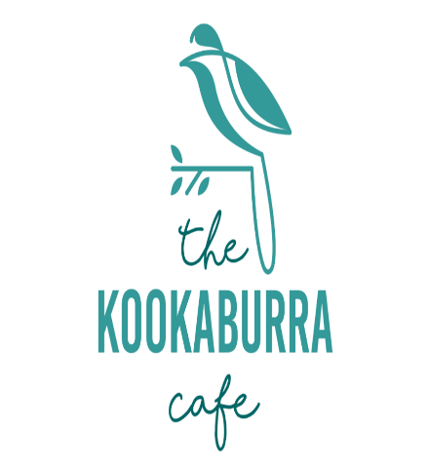Party Bookings at The Kookaburra Café

Name of child: ___________________

Date of party: ____________________

Please select a time for your food:

11:30am or 2:00pm

The following party items are served with chips and a fruit shoot style drink. Please tick which main the child has chosen.

|  |  |  |  |  |
| --- | --- | --- | --- | --- |
| Name of child | Nuggets | Veggie Fingers | Sausage | Cheese/ham sandwich |
|  |  |  |  |  |
|  |  |  |  |  |
|  |  |  |  |  |
|  |  |  |  |  |
|  |  |  |  |  |
|  |  |  |  |  |
|  |  |  |  |  |
|  |  |  |  |  |
|  |  |  |  |  |
|  |  |  |  |  |

We require at least **a week’s** **notice** for bookings and all food orders must be sent in **no later than 48 hours** prior to your party.

Please make sure you have checked availability in the Café before booking.

For further information or any questions, please email thekookaburracafe@gmail.com